**[F29DC 2024 Lab 1 - Connectivity, VPCs, Subnets, VLANs](https://canvas.hw.ac.uk/courses/28951/files/3694381?wrap=1" \t "_blank" \o "F29DC 2024 Lab 1 - Connectivity, VPCs, Subnets, VLANs.pdf)  
- Shyam Sundar Velmurugan  
- H00418621**{ Part 3 }   
Wireshark   
  
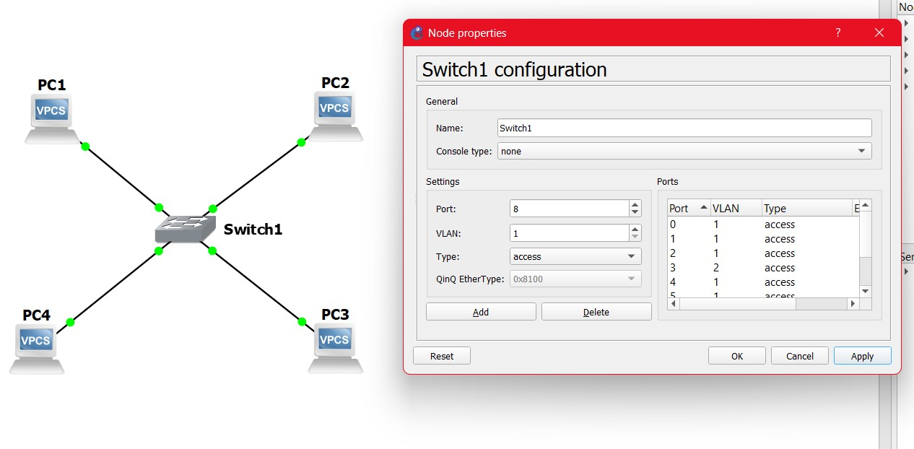  
Image 4.1: Reconfigure the connections of PC1 , PC2 & PC3 to the same network.   
  
  
  
  
  
  
  
  
  
  
  
  
  
  
  
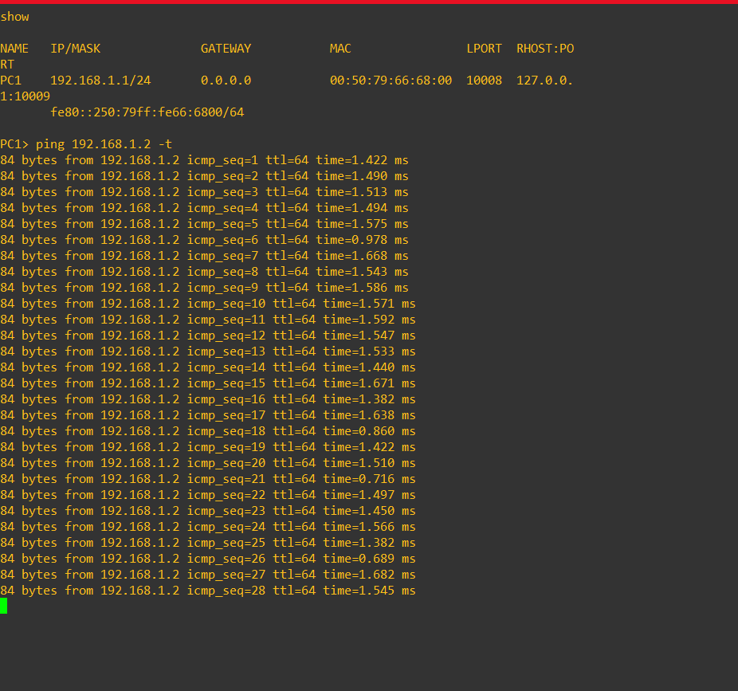  
Image 4.2: Starting a continuous ping from PC1 to PC2.  
  
  
  
  
  
  
  
  
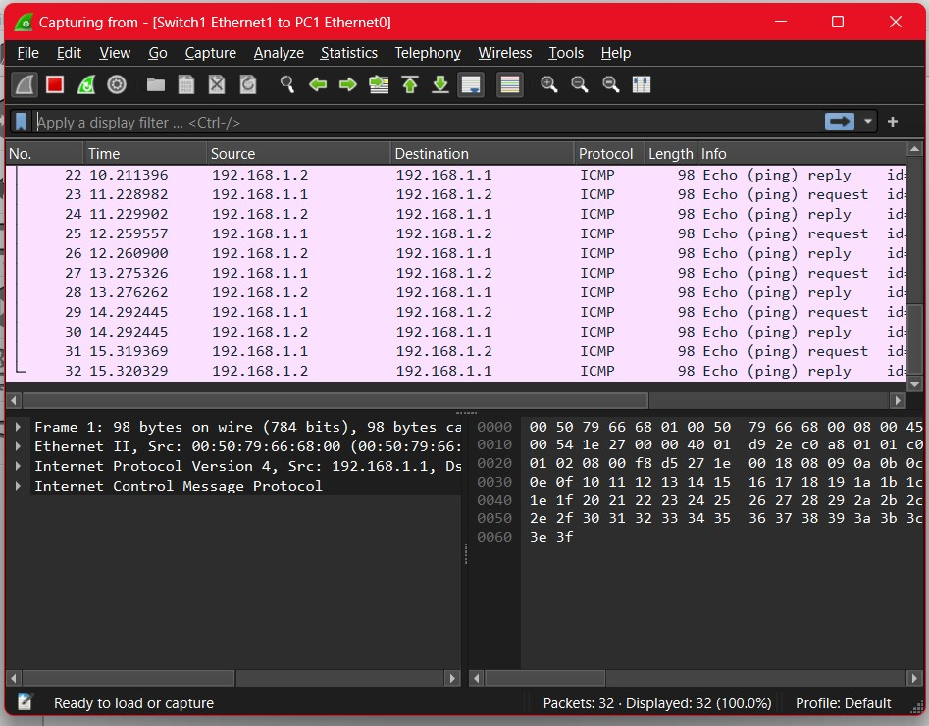  
Image 4.3: Start sniffing on PC1 link using wireshark.  
  
The protocol used for pinging was ICMP (Internet Control Message Protocol)  
  
  
  
  
  
  
  
  
  
  
  
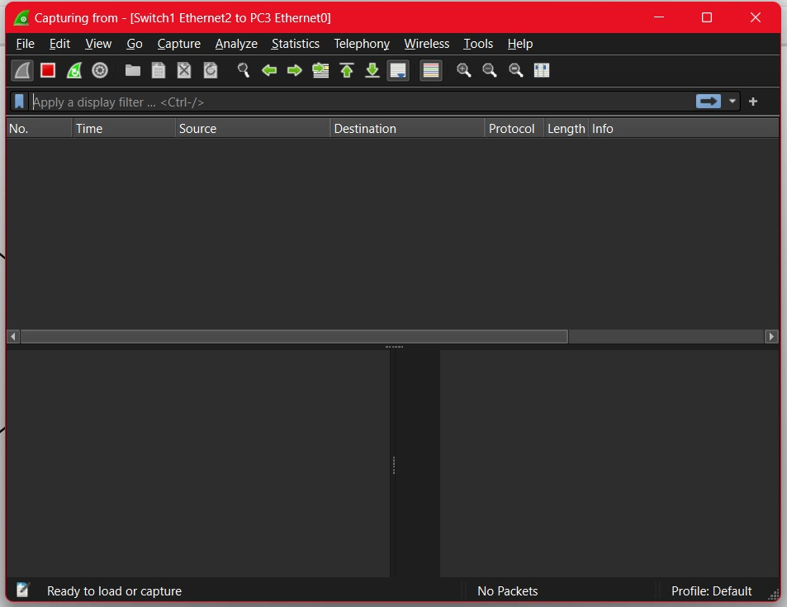  
Image 4.4: Start sniffing on PC3 link using wireshark.   
  
We cannot see a ping as PC3 does not have a continuous ping with any other PCs.  
  
  
  
  
  
  
  
  
  
  
  
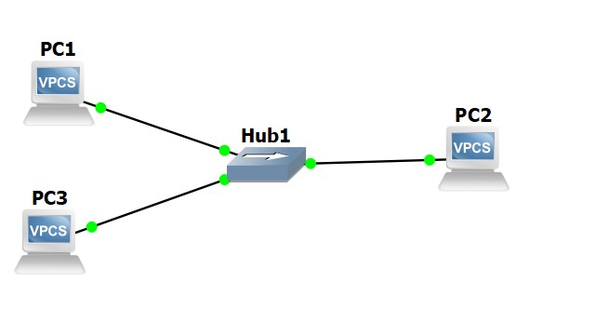  
Image 4.5: Replacing the switch with a hub.

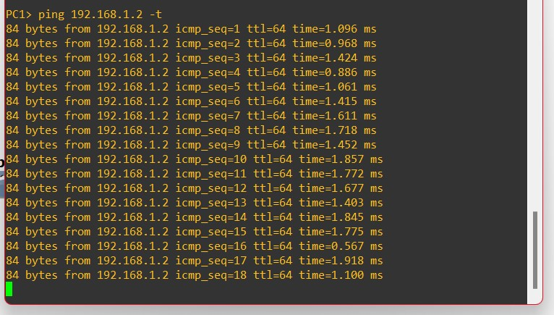  
Image 4.6: Starting a continuous ping from PC1 to PC2.

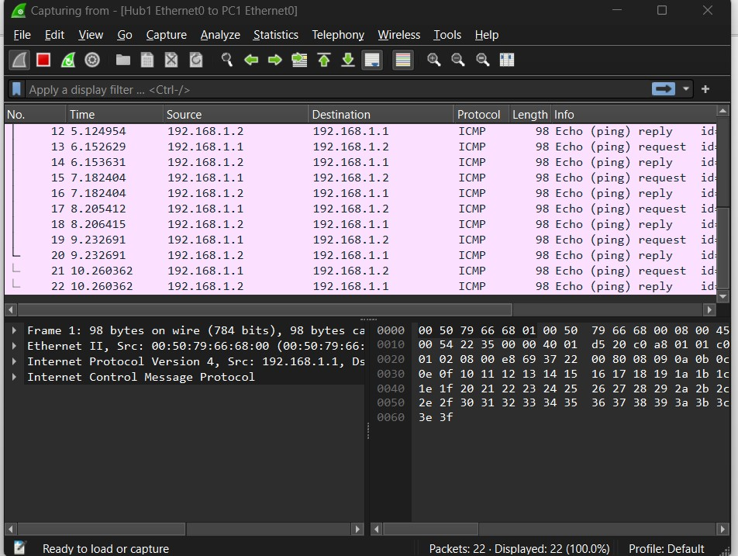  
Image 4.7: Start sniffing on PC1 link using wireshark.  
  
The protocol used for pinging was ICMP (Internet Control Message Protocol)  
  
  
  
  
  
  
  
  
  
  
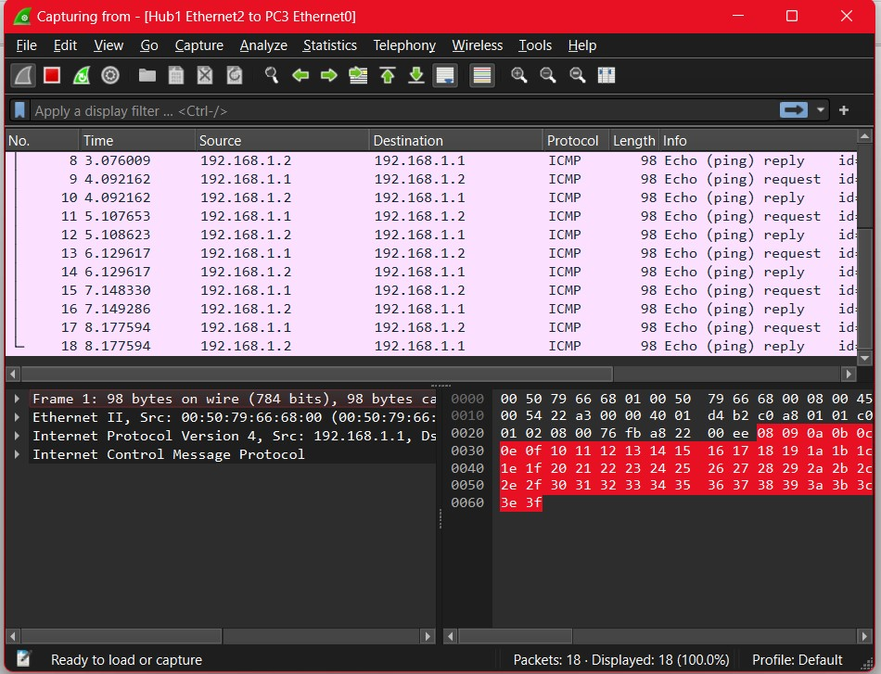  
Image 4.8: Start sniffing on PC3 link using wireshark.  
  
The protocol used for pinging was ICMP (Internet Control Message Protocol)  
  
Here we can see the pings present in PC3 are able to link as well with all the other PC’s connected as the Hub sends data to each other simultaneously.